Buttons / Call-to-Action (CTA)

Definition:
# Source: AI Source: Provided by: [Data Path: Persons Table -> ID Column: 1, Name_En Column: Motasem Essam] -> From: [Chatgpt (GPT‑5 Mini)] on [2/12/2026]
Buttons / Call-to-Action (CTA) are web page components designed to encourage users to take a specific action on a website. They are interactive elements that guide user behavior.

Simple Definition
# Source: AI Source: Provided by: [Data Path: Persons Table -> ID Column: 1, Name_En Column: Motasem Essam] -> From: [Chatgpt (GPT‑5 Mini)] on [2/12/2026]
Buttons / CTA = clickable elements that prompt users to do something, like buy, sign up, or download.

What Buttons / CTA Usually Includes
# Source: AI Source: Provided by: [Data Path: Persons Table -> ID Column: 1, Name_En Column: Motasem Essam] -> From: [Chatgpt (GPT‑5 Mini)] on [2/12/2026]
- Text – clearly states the action, e.g., “Buy Now,” “Sign Up,” “Learn More”
- Design / Color – stands out to attract attention
- Link / Functionality – redirects to another page, opens a form, or triggers an action
- Placement – often placed near important content or offers

Purpose of Buttons / CTA
# Source: AI Source: Provided by: [Data Path: Persons Table -> ID Column: 1, Name_En Column: Motasem Essam] -> From: [Chatgpt (GPT‑5 Mini)] on [2/12/2026]
- Drive user engagement and conversions
- Guide users to take desired actions
- Make it clear and easy what the next step is
- Highlight important offers or services

Examples
# Source: AI Source: Provided by: [Data Path: Persons Table -> ID Column: 1, Name_En Column: Motasem Essam] -> From: [Chatgpt (GPT‑5 Mini)] on [2/12/2026]
- E-commerce → “Add to Cart” or “Checkout Now”
- Blog → “Read More” or “Subscribe to Newsletter”
- Service website → “Request a Quote” or “Book Appointment”
- Educational site → “Enroll Now” or “Start Free Trial”

Difference Between Buttons / CTA and Links
# Source: AI Source: Provided by: [Data Path: Persons Table -> ID Column: 1, Name_En Column: Motasem Essam] -> From: [Chatgpt (GPT‑5 Mini)] on [2/12/2026]
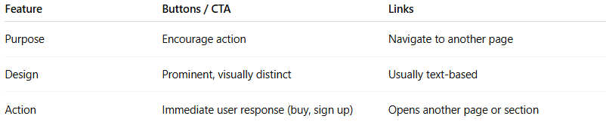
Feature | Buttons / CTA | Links
Purpose | Encourage action | Navigate to another page
Design | Prominent, visually distinct | Usually text-based
Action | Immediate user response (buy, sign up) | Opens another page or section

